INS3121
SOIL MECHANICS
MIDTERM EXAM II
December 08, 2014

Name Surname:
Q.1 | Q.2 | Q.3 | Q.4 | TOTAL
Number:
Group:

- a) Explain the concept of consolidation.

- Explain briefly normally-consolidated clay and over-consolidated clay. Which one has more convenient properties for foundation? Explain with reasons.

- What are the assumptions of “Terzaghi’s Consolidation Theory”?

Name Surname: Number: Group:
- The results of a consolidation test conducted on a soil specimen, which is recovered from field, are given in the following table. According to these results,
- Plot void ratio (e) – logarithmic pressure (log σ_{v′}) curve using the following semi-logarithmic graph.
- Determine the pre-consolidation pressure (σ_{p}’).
- Calculate the compression index (C_{c}) and swelling (recompression) index (C_{r}).

Pressure, σ_{v} (kPa) | 25 | 50 | 100 | 200 | 400 | 800 | 1600 | 400 | 100
Void ratio, e | 1.03 | 1.015 | 0.999 | 0.895 | 0.738 | 0.57 | 0.4 | 0.43 | 0.46
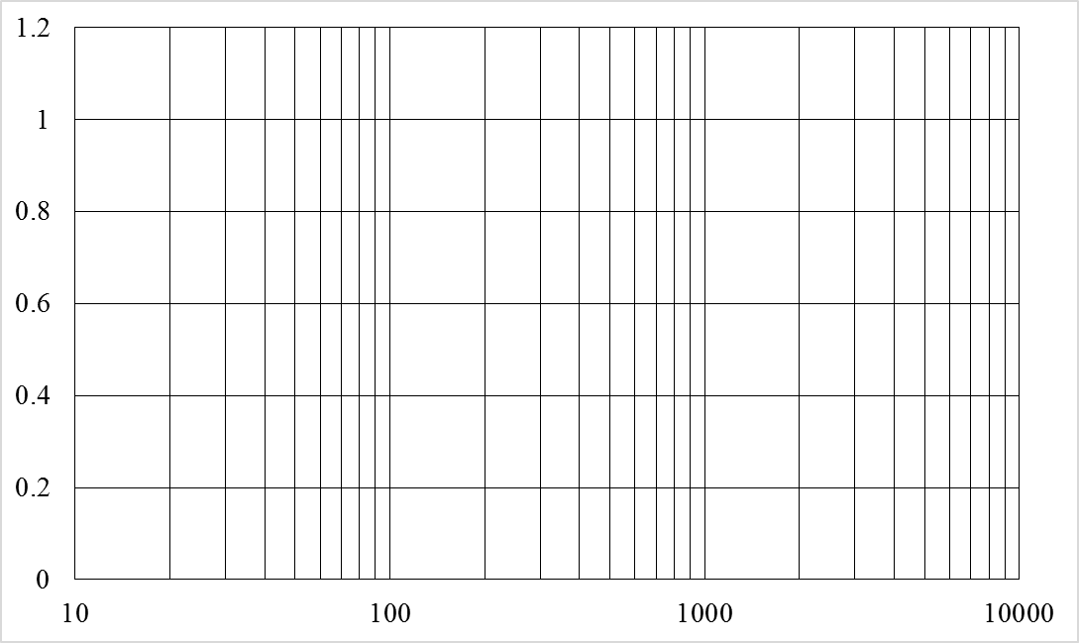

Name Surname: Number: Group:
- The net base pressure q_{net} of a uniformly loaded mat foundation, having 8 m x 16 m dimensions, is 120 kPa. Compute the stress increases (Δσ) at the corner and at the center of the foundation at a depth of 8 m by using Boussinesq method.

Name Surname: Number: Group:
- For the soil profile shown in the below figure ;
- By using the results of consolidation test conducted on a soil specimen recovered from the field, calculate the ultimate settlement of the clay layer when the GWT is lowered by 4 m. (The soils above GWT is assumed dry.)
- Compute the settlement of the clay layer after 1 year, if the coefficient of consolidation c_{v}=9.1x10⁻⁷ m²/min.

Pressure, σ_{v}′ (kPa) | 0 | 25 | 50 | 100 | 200 | 400 | 800
Void ratio, e | 0.66 | 0.65 | 0.642 | 0.623 | 0.574 | 0.51 | 0.445

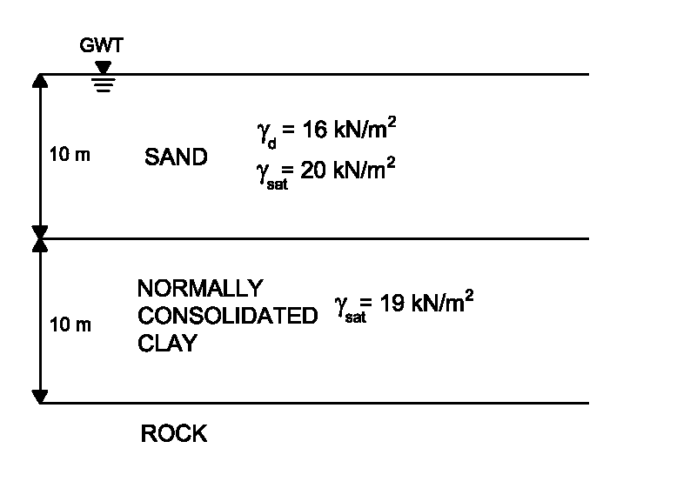
U (%) | T
10 | 0.008
20 | 0.031
30 | 0.071
40 | 0.126
50 | 0.197
60 | 0.287
70 | 0.408
80 | 0.567
90 | 0.848

Time75 minutes. Good Luck…

